User requirements



# TABLE OF CONTENTS

* Overview / goals (Section 1)  page 2
* Project Feasibility (Section 2)  page 3
* Analyzing requirements (Section 3) page 4-9
* Class diagram (Section 4) page 10
* Summary (Section 5) page 10

TA**User Requirements Document**

**Bike Rental Web Application**

**Overview**

# This document describes the user requirements for the bike and scooter rental web application. The platform is designed to offer a competitive and efficient means of transportation within the city, catering to the interests of various user groups.

# 1. Project Goals

## *Transportation*

One of the primary goals of the project is to create a system that is convenient to use within the city. The system should provide a high level of accessibility to transport and favorable conditions for its use.

## *Make City Travels Easier*

Our application aims to provide residents and visitors with easy-to-use transportation. This mode of transport serves as an excellent alternative to traditional options such as cars or public transportation due to its smaller size and high availability.

## *Affordable Rides*

Our goal is to offer a competitive transportation service without compromising quality, utilizing different payment approaches. Various tariffs will be available for different categories, including pay-as-you-go without subscriptions, flexible subscription plans, and subsidized subscriptions for students or other groups. Additionally, we want to promote a healthy lifestyle by offering reduced rates for those using non-electric transport.

## *A System Accessible to Everyone*

## Our system is designed to be accessible from different devices, ensuring a high-quality service regardless of the user's device. This also includes the implementation of various payment systems.

# 2. Project Feasibility

## *Timeline & Development Plan*

The project is planned for three iterations. In the first iteration, we will implement the features from the list of basic functions and create a minimal design. In the second iteration, we will introduce features from the list of extra functions, including subscription types, an interactive map, a promo code system, a referral system, user statistics, a QR code and numeric code system for transport access. We will also work on improving the design to make it more adaptable to different devices. In the third iteration, we will enhance the existing features by adding more payment options, additional support and notification channels, and we will focus on testing and bug fixing.

## *Potential Risks & Contingency Plans*

Missed Deadlines  
 A possible solution is effective team communication to synchronize our actions and work efficiently. As a last resort, we may consider reducing the scope of functionality.

Excessive Bugs and Issues with Testing in Later Development Stages

Competition

Since we will be newcomers to the market, it will be challenging to compete with larger and more well-known companies at the beginning.

A possible solution could be offering flexible plans for different user categories and creating attractive offers tailored specifically for them.

# 3. Analyzing requirements

# *Different Users – Different Needs*

## *City Guests and Occasional Users*

## For these categories, the main priority is to obtain the service quickly and without unnecessary hassle. They need transport here and now, without long-term commitments. This should be ensured through a minimal number of steps required to access transport and support for multiple payment methods, primarily international payment systems and bank cards.

## *Eco-Friendly Users*

We fully support the desire to reduce emissions and maintain a healthy lifestyle. For these users, we aim to offer better subscription conditions for specific types of transport that do not use electric motors. To encourage such users, we want to display statistics such as the amount of emissions they have avoided, calories burned, and other unique data relevant to the use of regular bicycles.

## *Special Groups*

## As a community of student , we understand the challenges that a complex or expensive city transport system can create. Therefore, we want to offer special subscription plans for students who can verify their student status.

## Core features

### *Find Transport*

### To ensure a great user experience, transport must be accessible, located in places where it is most needed, and available in sufficient quantity. Users should be able to easily find available transport nearby through an interactive map in the application.

### *Login*

For already registered users, a quick login system should be implemented to access transport rental and payment functions. Users will need to enter the credentials they used during registration.

### *Registration*

### To ensure a secure and reliable system, users must provide certain information that allows us to create an account and contact them if necessary. Registration enables users to rent transport, make payments, and access their personal accounts.

### *Payment*

### The system will support multiple payment methods to accommodate different user needs.

### *Admin Panel*

### A necessary tool for managing system operations, monitoring user statuses, and overseeing transport availability.

### *Booking Process*

### Users should be able to easily and quickly rent transport if they are registered and have completed payment. Users can also review their past transactions.

### *Support*

Essential for resolving any issues that users may encounter while using our system.

## Extra features

### *Subscription Plans*

To provide cost savings and more flexible services, users will be able to choose subscriptions for different time periods. This will reduce the number of transactions and include special subscriptions for students and eco-friendly users. For example, a user can subscribe for a whole day if they plan multiple trips, or for a month if trips are less frequent but regular

### *Interactive Map*

The map will display the user's location in the city and the nearest transport stations. Users will be able to check the status and condition of available bicycles or scooters, as well as the types of transport available at each station. Additionally, the map will show the operational zones of the application.

### *Cashback System*

Users who return transport to a designated station may receive a partial refund for their trip. This system ensures better availability of transport for others and makes it easier for the system to manage vehicle returns.

### *Promocode Feature*

Users will have the option to apply discount codes to their accounts or specific trips.

### *Referral System*

Registered users will be able to invite new users to the platform. Both the new user and the referrer will receive a reward for participation.

### *Language Versions*

Since the target audience includes residents of Dublin and other major Irish cities, the application will support at least two languages: Irish and English. This will make it convenient for both locals and visitors.

### *Multiple Support Channels*

Technical support will be expanded to include multiple communication channels, such as email, SMS, in-app messages, and messaging apps.

### *Credit System*

To reduce the number of transactions, users will have the option to top up their in-app wallet instead of paying for each trip separately.

***Accessibility***

For users who do not have access to their smartphone camera, an alternative method of unlocking transport will be provided. Instead of scanning a QR code, users can enter a generated access code.

### *Notification System*

A notification system will allow users to receive updates on special offers, new features, and important account updates via SMS, email, and in-app notifications.

### *User Stats*

### A personal dashboard will display detailed usage statistics, including trip duration, total distance traveled, amount of carbon emissions saved, calories burned, and a leaderboard ranking top riders in different zones.

### Example:

John, a frequent e-bike user, checks his dashboard and sees that he has taken 150 rides, traveled 500 km, and saved 80 kg of CO₂ this year. His favorite transport type is an electric scooter, and his most active day was May 10th. At the end of the year, he receives a personalized Wrapped-style summary comparing his stats to other users.

## *Use Case Diagram for Customers and Subscribers Using The Website*

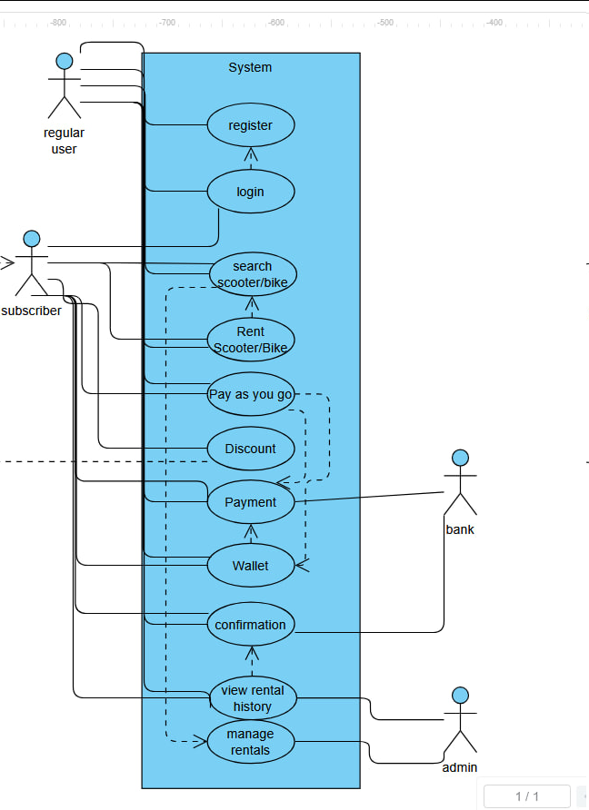

# *3.3 Use Case Descriptions*

|  |  |
| --- | --- |
| Use Case Id | 1 |
| Use Case Name | Pay as you go |
| Created by | Yones Ananzeh |
| description | The user will try to use the pay to go option |
| primary Actors | Customer |
| Secondary Actors | bank |
| Pre-Conditions | 1. The Customer must be on the website. 2. The Customer must have an account. 3. The Customer must have a debit or credit card. |
| Post Conditions | 1. The Customer will rent a scooter or bike using pay as you go. |
| Main Path | 1. The Customer accesses the website 2. The Customer logs in to the website 3. The Customer searches for a bike or scooter 4. The customer selects a bike or scooter. 5. The Customer selects pay to go 6. The Customer uses their payment card and needs to authorize the website with the bank. 7. The authorization is confirmed 8. The Customer can now directly pay for the time they use and it will take from the card automatically |
| Alternate Path | 1. The Customer accesses the website 2. The Customer logs in to the website 3. The Customer searches for a bike or scooter 4. The customer selects bike or scooter. 5. The Customer uses pay to go. 6. The Customer adds fund to their website wallet 7. They use their payment 8. The bank authorizes the payment 9. The Customer can now directly pay for the time they use from their wallet and any overtime will be taken from their card. |

|  |  |
| --- | --- |
| Use Case Id | 2 |
| Use Case Name | Subscriber rents a scooter |
| Created by | Yones Ananzeh |
| description | The Subscriber will try to rent a scooter from the website. |
| primary Actors | Subscriber |
| Secondary Actors | bank |
| Pre-Conditions | 1. The subscriber has access to the website 2. The subscriber must login 3. The subscriber must have goride credit or a payment card |
| Post Conditions | 1. The subscriber is able to use the rental and gets his discount |
| Main Path | 1. The subscriber accesses the website 2. The subscriber logs in to the website 3. The subscriber browses scooters 4. The Subsctriber rents a scooter. 5. The subscriber is discounted 10% 6. They use their payment card 7. The bank authorizes the payment 8. The subscriber has rented a scooter |
| Alternate path | 1. Steps 1-5 of the main path. 2. The bank does not authorize the payment due to lack of funds 3. The subscriber uses their wallet instead 4. The subscriber has rented a scooter |

4. Class Diagram

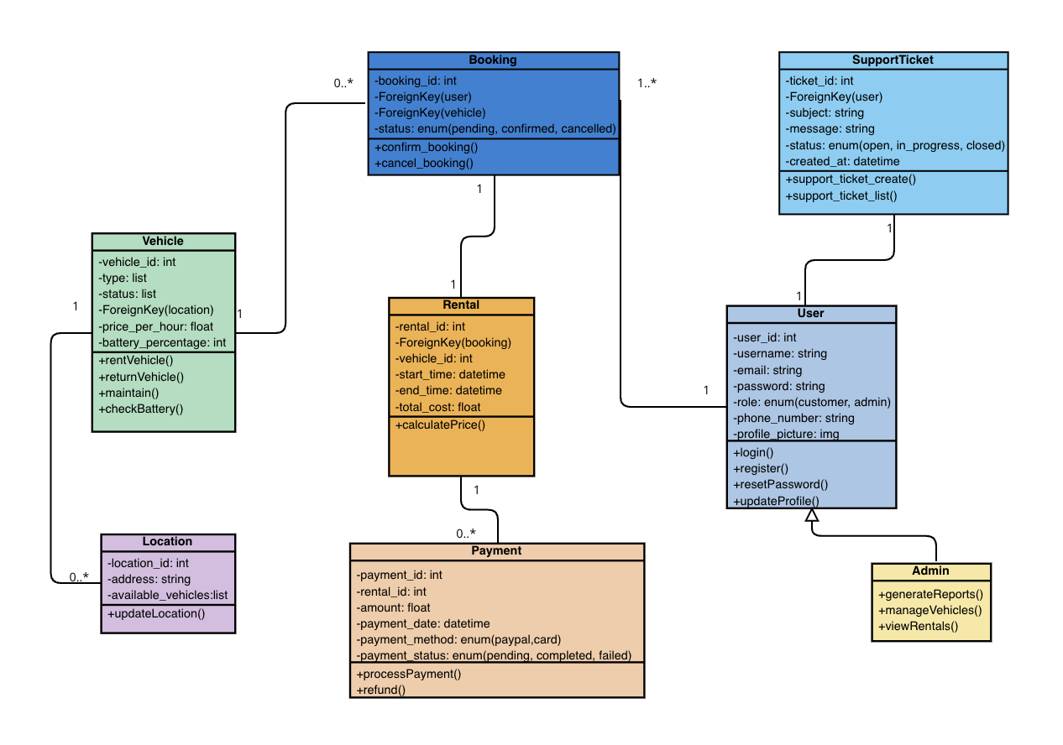

Picture 4.1 – Class diagram

**5. Summary**

This document outlines the goals of the project, how these goals will be achieved, and how they align with market and real-world challenges. It describes the project's features and visually represents the application's behavior through diagrams.

We have examined the potential risks the team may face during development and after the project's launch and proposed possible solutions. This document also covers the plans for the further development of the project.

**Contribution**

1. Goals of the project

Oleksandr Podynihlazov

2. Feasibility of project

Oleksandr Podynihlazov

3. Analyse requirements

Yones Ananzeh

Oleksandr Podynihlazov

4. Class diagram

Oleksandr Kurilets

5. Summary

Oleksandr Podynihlazov

6. Design & Table of content

Oleksandr Podynihlazov

Yones Ananzeh

Oleksandr Kurilets